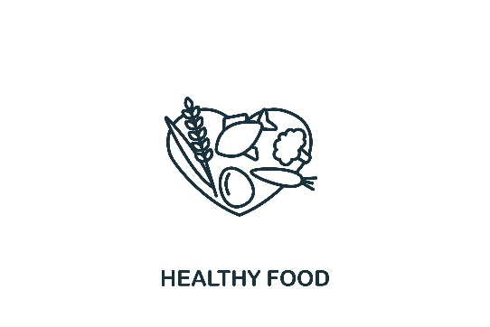Food

* **Find a Food Pantry** – PA Department of Human Services Food Pantry Locator by address: [www.dhs.pa.gov/about/Ending-Hunger/Pages/Food-Pantries.aspx](http://www.dhs.pa.gov/about/Ending-Hunger/Pages/Food-Pantries.aspx)
* **Fresh Connect** – Every Thursday 11am-noon in Ottsville (corner of 611 and 412) – weekly outdoor food pantry/farmer’s market. Registration on site. There is also one in Warminster every Tuesday.
* **Fresh For All** – Every Tuesday 12:00-1pm, receive 20-30lbs of free produce! No ID, area of residence, or income verification required. Basic household information collected, but there is no qualification for the program. Grace Bible Church, Main Street & Summit Ave, Souderton PA (Across from Wawa). Please bring bags or boxes to carry your food.
* **FreeFood.org** – Pennsylvania free food resources
* **Feeding America Food Banks** – [w](http://www.feedingamerica.org)*[ww.feedingamerica.org](http://www.feedingamerica.org)*
* **Women, Infant and Children** *–* [*www.fns.usda.gov/wic*](http://www.fns.usda.gov/wic)
* **School Breakfast Program** – [*www.fns.usda.gov/sbp/school-breakfast-program*](http://www.fns.usda.gov/sbp/school-breakfast-program)
* **Supplemental Nutrition Assistance Program (SNAP**) – [*www.fns.usda.gov/snap/supplemental-nutrition-assistance-program*](http://www.fns.usda.gov/snap/supplemental-nutrition-assistance-program)
* **Bux-Mont Meals on Wheels** –Home bound residents of Bucks and Montgomery County.

Meals are delivered every Monday through Friday.

Call: (215) 443-9784

Email: [coord.buxmontmow@gmail.com](mailto:coord.buxmontmow@gmail.com)

* **United Way** – **(**if need assistance with food, housing/housing needs, medical and dental clinics, or other resources) [www.211unitedway.org](http://www.211unitedway.org)

Call: 2-1-1 or 800-543-7709

Text your zip code to 898-211

* **Meals America** – Healthy meals for seniors on Medicaid or Medicare [www.mealsamerica.com](http://www.mealsamerica.com)

Call: 215-399-5676